ZephyrDesk : Technical Document

|  |  |
| --- | --- |
| **Version** | **Author** |
| 1.1 | Team Damco |

# Scope of document

This document outlines the technical aspects of the ZephyrDesk. It highlights the system architecture, high-level automation flows, and business workflows which would give the users an overview of the overall system.

# Revision History

|  |  |  |  |
| --- | --- | --- | --- |
| **Version** | **Date** | **Modified By** | **Comments** |
| 1.0 | 30-Apr-2023 | Ashish K Narwal | Initial Draft |
|  |  |  |  |

# Table of Contents

Scope of document 1

Revision History 1

Table of Contents 1

1. App architecture 2
   1. Platform/Technologies 2
   2. Architecture Diagram 3
   3. Licensing 3
2. Database ERD 3

￼

1. Workflows 12
2. Business logic notes 14
3. Business Rules 20
4. Limitations 26
5. Onboarding instructions 27

# App architecture

1. Platform/Technologies

The app is built using various Microsoft components, based mainly on Power Platform. Below table lists down the main components used for building this application and their description.

|  |  |  |
| --- | --- | --- |
| **Component Name** | **Type** | **Description** |
| PowerApps | Power Platform | PowerApps is a component of the Power Platform, provided by Microsoft, which allows anyone to automate and build applications that improve business processes in minutes, with no code or very little code.  We have used Model-Driven PowerApps to build this application. |
| Power Automate | Power Platform | Power Automate is a workflow service provided by Microsoft that helps you to create automated workflows between desired services to collect data, send notifications etc., to accomplish repetitive, manual, and time-consuming tasks without human intervention. |
| Dataverse | Power Platform | Dataverse is a relational, low code data platform which runs on top of Azure. It comes with a rich security model. |
| Office 365 Outlook | Microsoft service | This application is using office 365 outlook connector  to send email notifications using Power Automate. |

**TABLE 1: INCLUDED PLATFORM/TECHNOLOG IES AND/OR SERVICES TABLE**

1. Architecture Diagram

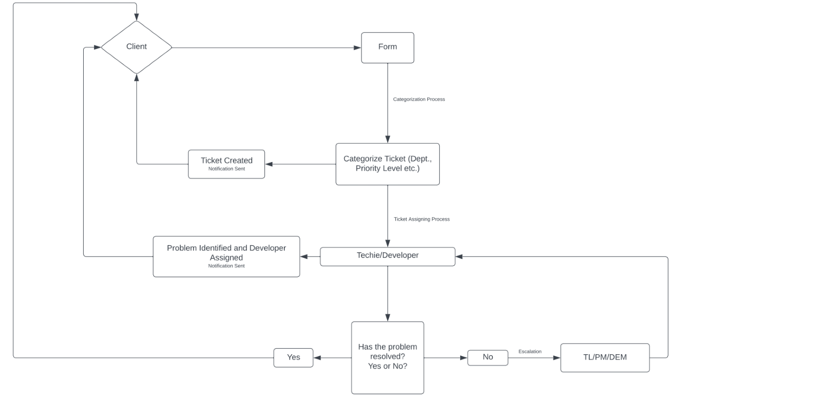

1. Licensing
   * Microsoft Office 365 –
   * Power Apps Per User Plan –
   * Power Apps Per App Plan –

# Database ERD

We are using Power Platform Dataverse as a back-end Data-source for this application.

Direct Link to the data model diagram of the app: [Link](https://lucid.app/lucidchart/cf46cbf3-9cbb-4299-87f7-0a132dee0110/edit?viewport_loc=-68%2C328%2C2559%2C932%2C0_0&invitationId=inv_0c0e96ff-86e9-4821-81c0-635516fa4089)

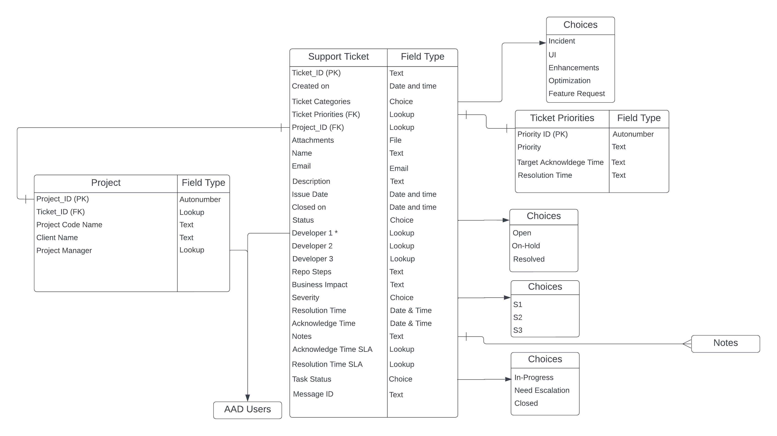

Below section describes the main tables contained in this solution, along with their purpose.

|  |  |
| --- | --- |
| **Table Name** | **Purpose** |
| AAD Users | This virtual table provides a connection to Azure Active Directory (AAD) and returns data about users within your AAD organization. No virtual table configuration is required to use the functionality. This is an online only feature. This table is linked to Support_Tickets |
| Notes | This table contains special string columns that store the file data. This Ticket is linked to Support_Tickets table. |
| Projects | This table stores details about projects and is linked to Support_Tickets table and AAD Users. |

|  |  |
| --- | --- |
| Support_Ticket | This table stores all the details about all the tickets ever created and is linked to Projects, Ticket_Priorities and AAD Users tables. |
| Ticket_Priorities | This table stores details about ticket Priorities and is liked to Support_Tickets table |
| ZephyrDesk Business Process | This table stores all the details about Business Process Flows used in the application. |

# Workflows

Below table lists down the power automate flows created to automate various processes/features of the application.

|  |  |  |  |
| --- | --- | --- | --- |
| **S. No.** | **Workflow Name** | **Trigger** | **Purpose** |
| 1 | Create Ticket | Automated – When a MS Form is Submitted | This flow is triggered automatically when the client submits the Microsoft Form. It extracts and saves all the information submitted by the client along with Email’s Message ID. |
| 2 | Developer | PowerApps – Field Change | This flow is triggered when any of the three Developer’s fields are changed or modified. It sends the developer an email and adds a note to the notes table. |
| 3 | Feedback | Automated – When a MS Form is Submitted | This flow is triggered automatically when the client submits the Microsoft Form. It has customer feedback details. |

|  |  |  |  |
| --- | --- | --- | --- |
| 4 | SLA - Developer | PowerApps – Field Change | This flow is triggered when the Ticket Priorities field is changed from the application, and it calculates and saves the targeted Acknowledge and Resolution Time for the ticket along with Ticket Priorities. |
| 5 | SLA - Manager | Automated - Recurrence | This flow is triggered automatically every weekday and checks for tickets left unattended tickets for equals to or more than 2 days and sends the manager a reminder email with the list of all the tickets at 10:40 AM |
| 6 | Status | PowerApps – Field Change | This flow is triggered automatically when the Status Field is changed from within the application and sends communication emails to the client on the ticket status. |
| 7 | Task Status | PowerApps – Field Change | This flow is triggered automatically when the Task Status Field is changed from within the application and sends communication emails to the manager on the task status on the ticket. It also saves the actual Acknowledge and Resolution Time. |
| 8 | Ticket Reopen | PowerApps – Field Change | This flow is triggered automatically when the Ticket Reopen field is changed from within the application and communicates to the client and as well as the manager. |

# Business Logic – ZephyrDesk Business Process Flow

* 1. **Stage 1 Project Manager** --> Project Manager will set up Ticket Priorities (P1, P2, P3, P4) and assign at least 1 Developer. As soon as the Priorities are set, and a developer is assigned the developer will be notified of the task via email while another flow will calculate the Targeted Acknowledge Time and Resolution Time for the task to be completed and the Status of the Ticket will be changed to In-Progress from Open.

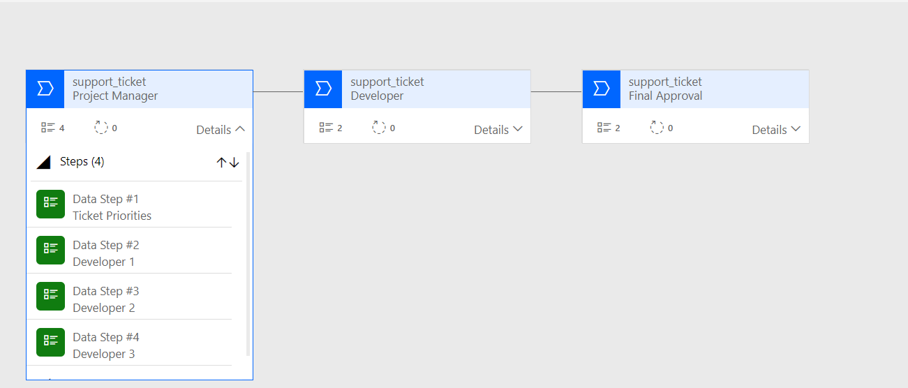

* 1. **Stage 2 Developer -->** At this stage the Developer will set the Ticket Categories using the options available in the drop-down menu and will start working on the ticket. If the developer requires any assistance from the client or project manager in terms of more information on the ticket/task at hand or needs more resources to complete the task in the stipulated time respectively, he/she can change the Task Status to Need Escalation. This will inform the project manager via email about the assistance. Developers can put the ticket on Hold depending on his/her understanding of the issue. Once the task is completed Developers need to change the Task Status to Closed soon as possible to record and make a note of the Actual Acknowledge Time and Resolution Time. This will also notify the Project Manager of the task completion for review of the work.

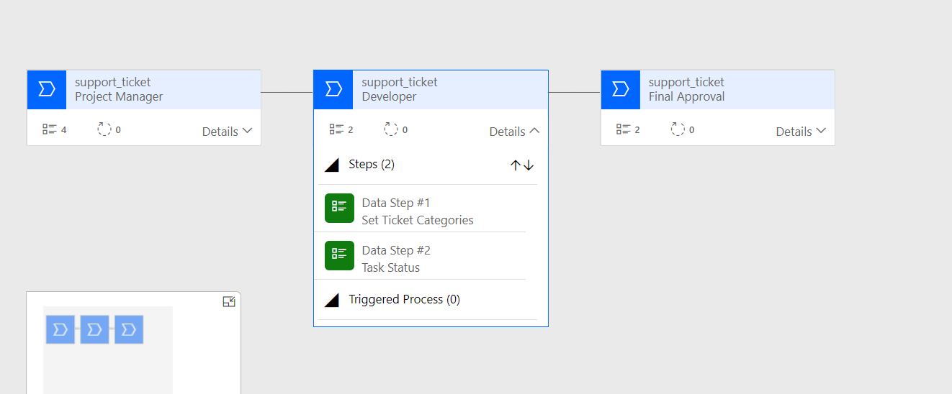

* 1. **Stage 3 Project Manager -->** At the last stage the Project Manager will review the work and if satisfied will change the Status to Resolved which in turn will notify the customer about the resolution of his ticket. The Project Manager also has the option to reopen the tickets on customer demands.

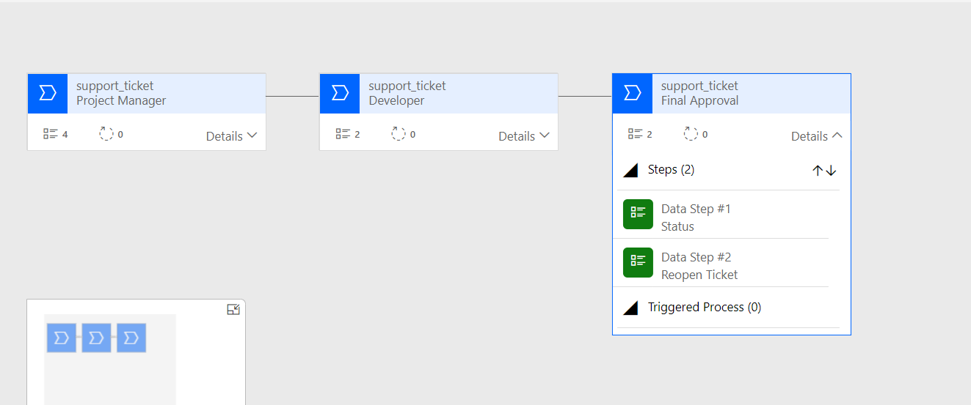

# Business Rules – ZephyrDesk Ticket Reopen Business Rule

**Note:** Ticket Reopen Business Rule will ensure the reopening of the ticket only in the case it has been resolved once and its status has been put under closed.

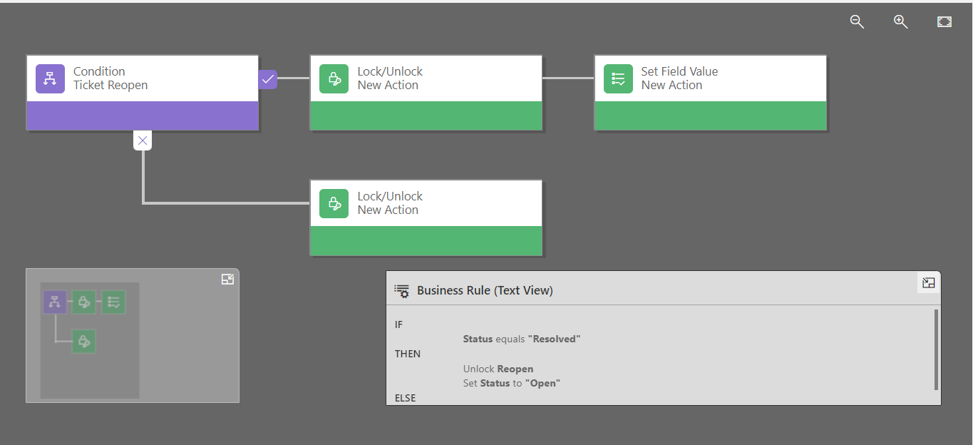

# Technical notes

* 1. **Security Roles** --> Security roles in PowerApps are thesettings that control the access and permissions of users and groups in an environment. 2 different security roles have been defined for the application. One each for the Project Manager and Developers which defines the limit of their use of the application specific to their needs and usage.
  2. **Connection References -->** Connection references are used in the Power Automate Flows, so no further configuration is needed after the solution is transferred to the target environment. Note: A connection reference is a solution component that contains information about a connector. Both the canvas app and operations within a Power Automate flow bind to a connection reference.
  3. **Service Account -->** Service account has been used for the connection reference for the Office 365 connector to be used in the email.